

CSE471 : System Analysis and Design
Lab Assignment on Figma
Project Title : Buyer Portal and Upload Invoice

Group Number : 4
Submitted by : Mihir Das
Student ID : 22299480
Section: 09
Date : 14/7/2026

Figma Link: Assignment 2
Prototype Link: Assignment 2

Feature 1: Buyer Portal
The Buyer Portal provides a centralized dashboard for managing invoices, supplier payments, and overall supply chain finance activities. Buyers can review pending confirmations, track confirmed payables, monitor upcoming payments, manage disputes, assess supplier risk, and view cash-flow or liquidity forecasts. It gives the finance team a clear overview of important actions and financial information in one place.

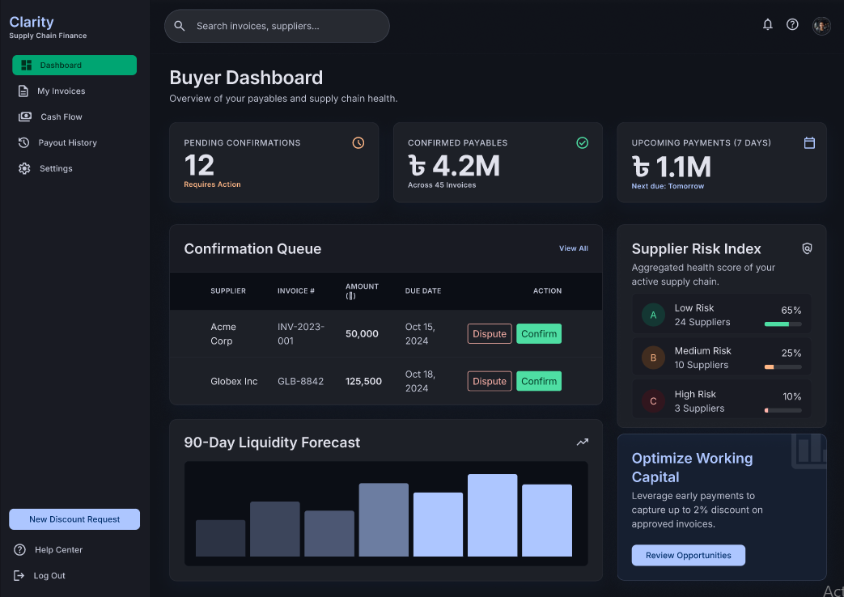
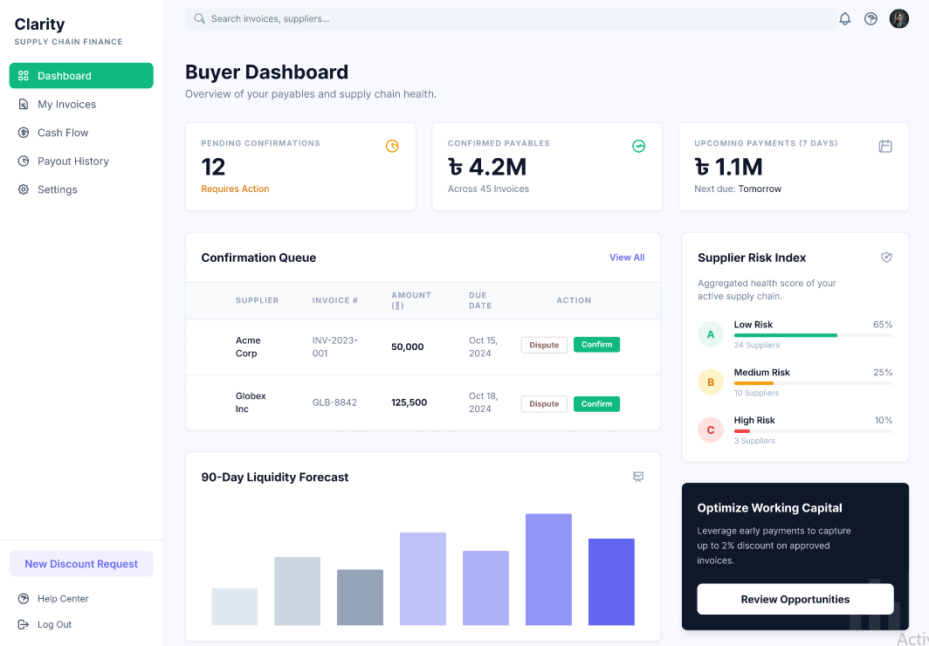
Feature 2: Upload Invoice
The Upload Invoice feature allows buyers to upload supplier invoices through drag-and-drop or manual file selection in supported formats such as PDF, JPG, and PNG. The system uses AI to extract important information, including the supplier’s name, invoice number, total amount, and due date. Users can review the original document alongside the extracted data, correct any inaccurate details, and submit the verified invoice for confirmation and further payment processing.

